My Home Group

My Home Group Minutes

Meeting held on Wednesday 26 June 2024, The Square at 11am

In Attendance

**MHG Members Apologies**

Christopher McMillan Wendy Hall

Sharon Monk Caroline Houston

Caroline Kay

Doreen Kay

Joe McNee

David Ritchie

**Other Attendees**

Brenda Murphy (Housing Officer)

Tracy Henderson (Housing Assistant)

Welcome Introduction

Tracy welcomed everyone and general discussion took place.

|  |
| --- |
| The group recapped on the previous minutes. The group feedback that the tenant guide – kitchen upgrade works leaflet needs to be condensed and more pictures would be great. An audio version would be helpful. |

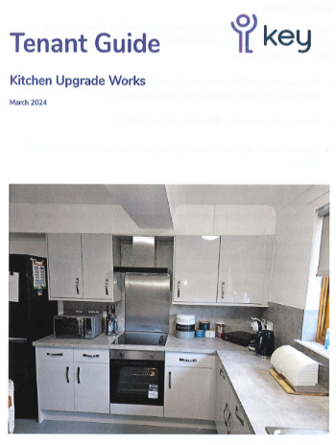

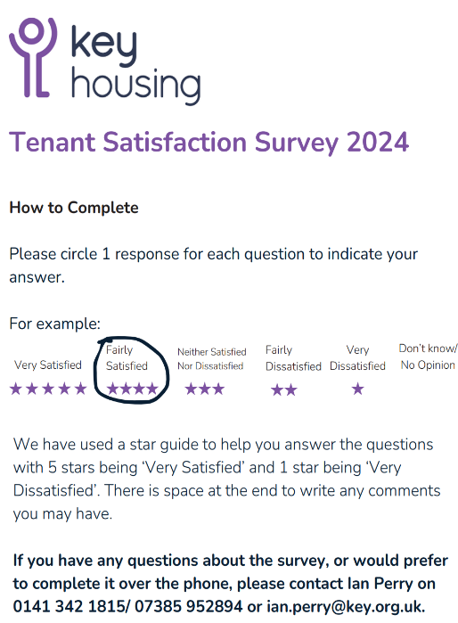

|  |
| --- |
| The group reviewed the results of the recent Tenant Satisfaction Survey 2024. Whilst there were some good results the group noticed some areas where Key needs to improve. We will look at these areas in more detail in meetings to come. |

Tenant Satisfaction Survey

Minimum Void Relet Standard

|  |
| --- |
| Brenda discussed the minimum void and showed pictures of a void property. Brenda explained that the Housing Officer would check what is in good condition and what would need to be replaced. There is often work required with repairs, deep cleaning and lifting carpets to get the property up to a reasonable, safe standard before a new tenant can move in. |

|  |
| --- |
| Tracy informed the group that the next AGM will be taking place on 11 September and the My Home Group have been invited along to take part.  The My Home Group suggested it would be a great idea to hold a stall to advertise the group and encourage new members to join. |

AGM

Quiz – Summer – Prepare home to leave when going on holiday

Tracy went over the quiz and the group discussed keeping their home safe and preparing to leave their home for longer periods of time.

Next Meeting

To be arranged.

The meeting concluded at 12.30 pm.

If you have any questions about the My Home Group, please call 0141 342 1810 or email brenda.murphy@key.org.uk