My Home Group

My Home Group Minutes

Meeting held on Wednesday 20 March 2024, The Square at 11am

In Attendance

**MHG Members Apologies**

Christopher McMillan David Ritchie

Caroline Kay Caroline Houston

Doreen Kay

Joe McNee

Sharon Monk

Wendy Hall

**Other Attendees**

Kirsty Sweenie (Tenancy Services Team Manager)

William Blackett (Property Maintenance Team Manager)

Brenda Murphy (Housing Officer)

Tracy Henderson (Housing Assistant)

Welcome Introduction

Kirsty welcomed everyone and general discussion took place.

The group recapped on the previous minutes.

Planned Replacement Programme

My Home Group

Planned Replacement Update

Wednesday 20th March 2024

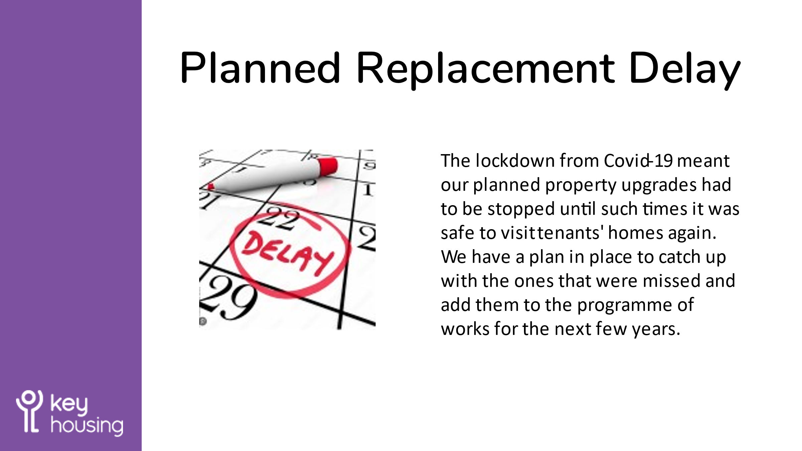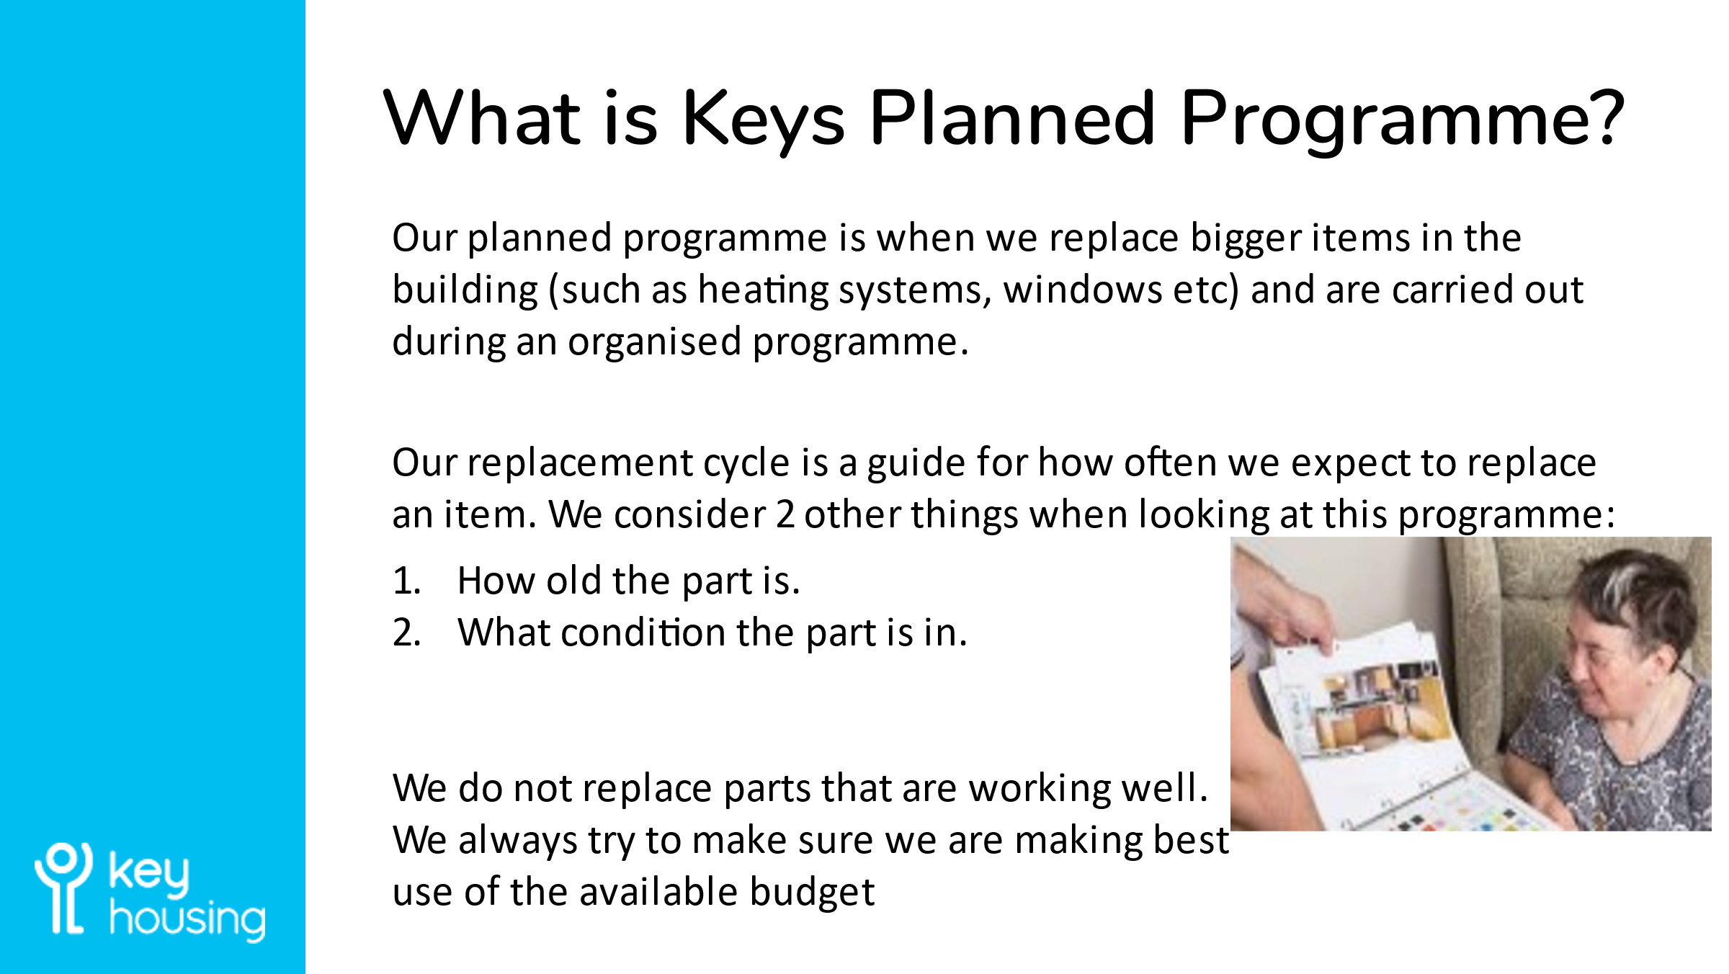

|  |
| --- |
| William Blackett introduced himself and then went over Key’s maintenance replacement programme. William explained the replacement cycle of the bathrooms, kitchens, windows, roofs, and heating systems.  A small sample of the new window material was passed around the group for views. Instead of painting the windows they will be made with different materials which won’t require the same maintenance and upkeep. The group felt the new windows looked nice, much more robust for the weather and modern.    The group were informed by William the impact of Covid and contractors which has delayed the replacement programme. The group were made aware the programme should catch up again within the next 2 years. |

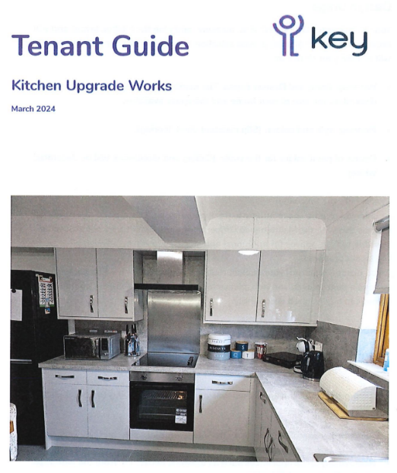Tenant Guide – Kitchen Upgrade Works

|  |
| --- |
| William asked the group to look over the leaflet and welcomed any feedback.  The group agreed to take this away and read over this and agreed to give any feedback at the next meeting. |

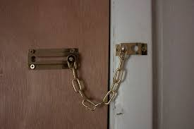Tenant Safety

|  |
| --- |
| William informed the group and explained door safety and the use of door chains.  William advised the only use for door chains. Door chains must only be used when someone is at the door, this allows that extra level of safety.  The chain allows the person to check who is at the other side of the door before opening the door fully.  They must never be used all the time because this would prevent the tenant receiving help quickly in the event of a fire or any other emergency. |

VOID Property Visits

|  |
| --- |
| Brenda discussed with the group the idea of members visiting some of the void properties. This would allow them to see first-hand the process and requirements that need to be met before another tenant moves in. A few members were interested and would like to visit to check out the procedures and work required. |

Spring Quiz

The group enjoyed spending time generally discussing springtime. Members of the group all participated and noted the clocks changing. The group agreed that it’s nice being able to open windows again for fresh air and lighter nights make it easier to get out more.

Next Meeting

To be arranged.

The meeting concluded at 12.30 pm.

If you have any questions about the My Home Group, please call Tracy Henderson on 0141 342 1810 or email tracy.henderson@key.org.uk